PharmaSUG 2023 - Paper AP-117

Automatic CRF Annotations Using Hash Tree Algorithm

Pengpeng Li, BioEvov Company;

# Abstract

Of utmost importance to both sponsor and CRO companies is ensuring high quality and efficiency when generating SDTM aCRFs. This is because SDTM aCRF is a crucial element in the SDTM submission package, and many pharmaceutical MNCs have established their own company-level SDTM aCRF standards in addition to CDISC guidelines. To guarantee success in the highly competitive pharmaceutical industry, it is essential to carefully follow both CDISC and company-level SDTM standards when generating SDTM aCRFs. In this paper, we present a novel way which relies on a meticulously crafted infinite-dimensional and regular expression compatible Hash Tree structure to automated generated annotated aCRF with quality and efficiency. The Hash Tree only store the hierarchical structure and textual continent of PDF and dump it into JSON format file. After adding annotation information, the programs rescan the PDF file and add annotation by the guide of annotation-contained JSON file. This method can position and locate of comment automatically with no reliance on page number or absolute coordinate of textual elements ,additionally possesses loose coupling capability and is easy for comments migration, making it convenient for multiple collaborators to modularly handle lengthy documents.

# Introduction

The genesis of SDTM production lies in the annotation of vacant CRF pages, which must be packaged alongside SDTM datasets as an integral element of the clinical data submission package to the Food and Drug Administration (FDA). For statisticians and programmers, the laborious task of manually annotating CRFs using the Adobe Acrobat comment tool presents a hurdle. They have struggled to mechanize this process, yet, most of the current techniques or packages rely on the use of multiple software. These methods generate Forms Data Format (FDF) files for import substitution into blank CRFs. These approaches record poor annotation performance when applied to unprecedented CRFs or versions of CRFs that undergo radical transformations. Other method such as using R tm package or python's PyMUF2 packages to capture text blocks in PDF file and simply arrange a number to each question solely by vertical coordinate of neighbored line break and organizing data which finally store in EXCEL. For most case, it will contain mistakes for PDF parsing result whose structure in not consistent with Study Design Specification (SDS) file which is not always available for annotating CRF and bring unexpected annotation mistakes. To surmount this pitfall, we have developed a Python module that capitalizes on the influential characteristics of Python to annotate CRF pages automatically. Our package supersedes customary methods and other computerized tools by providing significant attributes, including:

* Abandoning coordinate systems, EXCEL, or FDF files, we propose utilizing a meticulously designed data structure based on the "Hash Tree" to record the entire structure and textual continent of the CRF form. This data structure will generate a JSON file containing all possible annotation positions. Users can directly modify the JSON file to enable automatic annotation of the desired text. Annotation width and position are automatically calculated by the system and integrated into the generated JSON file without human intervention.
* There is no need to ensure the correctness of CRF structure parsing. As long as the input parameters are accurate, all possible annotation positions will be traversed, even if the document structure parsing results do not match expectations. The annotation effect will not be affected by any discrepancies.
* Users do not need to pay attention to the PDF file itself, only edit the parsed JSON file to achieve highly reliable document annotation results and greatly improve efficiency. Furthermore, related editors can format and display the JSON file, facilitating a better understanding of the document by workers and enabling them to work without reference to the source document.
* This task is highly modular and portable. A large CRF PDF file can be divided into multiple totally independent sub-documents and completed collaboratively by multiple personnel. The data structure then combines the annotation results without losing any data integrity. This means that the once cumbersome and labor-intensive work can now be completed by teams working by divide-and-conquer strategy. Additionally, if necessary, the project can even be open-sourced on Github.
* Annotation migration becomes possible. Based on Python's build-in functions, annotation updates and comparisons for multiple different versions of the same document can be performed through key-value pair conversion, enabling seamless annotation migration to the required result without data loss.
* The system supports regular expression matching, and the annotated text can be synchronized based on specific variables. Standard regular expressions can be used to enable the annotated text to change automatically with the matching variables. This greatly simplifies the workload for some tasks.
* The annotation records are stored in the JSON format file and can be easily dumped into databases such as MongoDB, Redis, and jsonDB, enabling remote management and remote work needs at any time. Furthermore, database management can also bring benefits to task management.
* The system has a complete command-line tool and graphical user interface. Apart from editing the JSON file, all other steps are basically automated.

# WROKFLOW AND PROCESS

## Data Structure for storing data

First of all, we design a specific data structure to store the parsing result of CRF PDF file. Our ultimate goal is to create a self-expandable infinite-dimensional Hash Tree that can perform regular expression fuzzy matching we package this data structure as a class named **MultiRegexDict**. We can simply understand this data structure as building a super directory that records the structure and textual content of the entire CRF document. After testing, we could clearly find we fulfill the envisioning that the **MultiRegexDict** class supports automatic self-expandable and regular expression fuzzy matching.

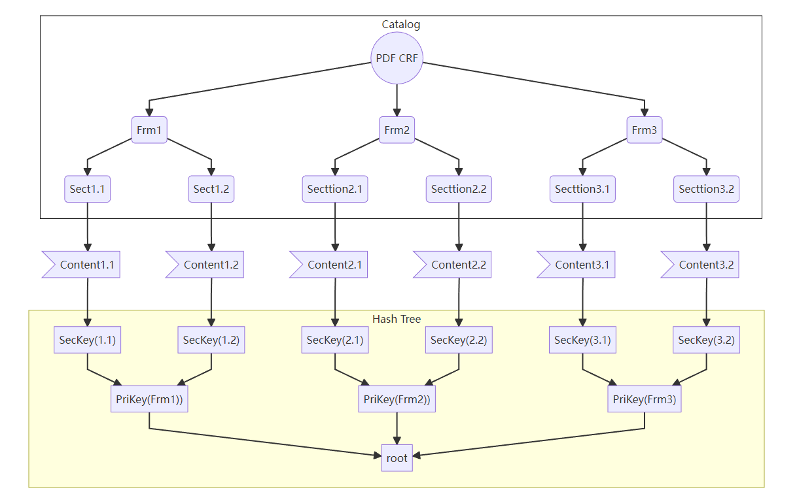

Figure Hash Tree [schematic diagram](javascript:;)

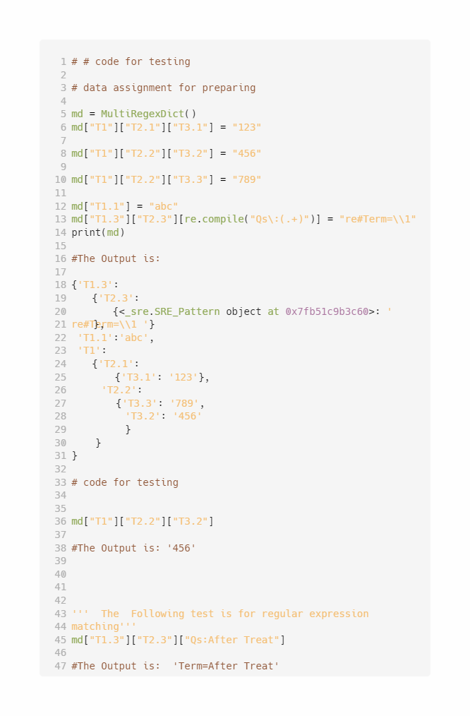

Figure . Testing code for data structure to store PDF parsing result

## workflow

Based on the **MultiRegexDict** class, we design an automatic workflow for CRF annotating. The whole process consists of 3 steps , and a series of python scripts have written to fulfill the function.

1. Parsing PDF file and map corresponding Heading to **MultiRegexDict** class and dump it into a JSON file.
2. Edit the JSON file and add annotation .
3. Map back the Annotated JSON to Blank CRF PDF file to generate Annotated PDF File.

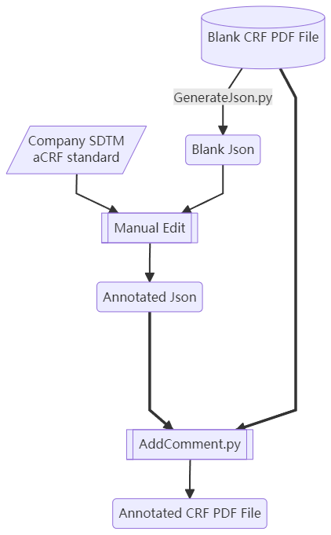

Figure . Brief workflow overview

### Parse an Extract Content Structure into JSON

When you submit a CRF PDF, the initial software comes in handy as it enables the extraction of all the relevant information from the aCRF. This includes the text content, placement, fonts, as well as text coordinates. You can provide the program with a pre-established regular expression or a predefined config file in order to facilitate the identification and differentiation between the text categories such as titles, form names, or general content. By relying on the established rules, the software is able to capture the relevant data and then collate it using a python **MultiRegexDict** class in a hierarchical fashion by concatenating the form names, variable names, and annotations. In the case where the user has not provided any configuration information, the program will conduct a line-by-line scan of the text blocks present on the page, and subsequently sort them based on their horizontal coordinates. It will then proceed to hierarchically dump these objects into relevant data structures as key on different level. Using such a structured approach means that data is easily organized and can be retrieved quickly when needed.

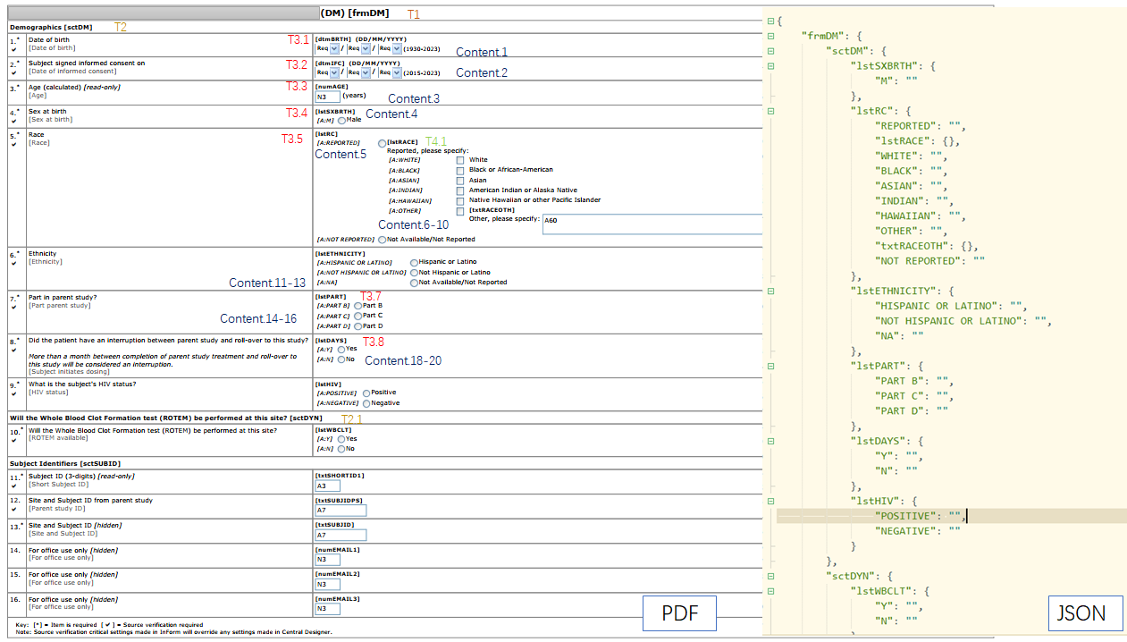

Figure . PDF document parsing principle schematic diagram.

### Edit JSON File and Add Annotation

Use the Editor support JSON format to edit JSON file and add value attribute on the text you want to annotate. The content being edited is highlighted in the red box as shown in the The left half of the figure below. If the attribute start with **compile#** and **re#**, that means the regular expression for matching and output.

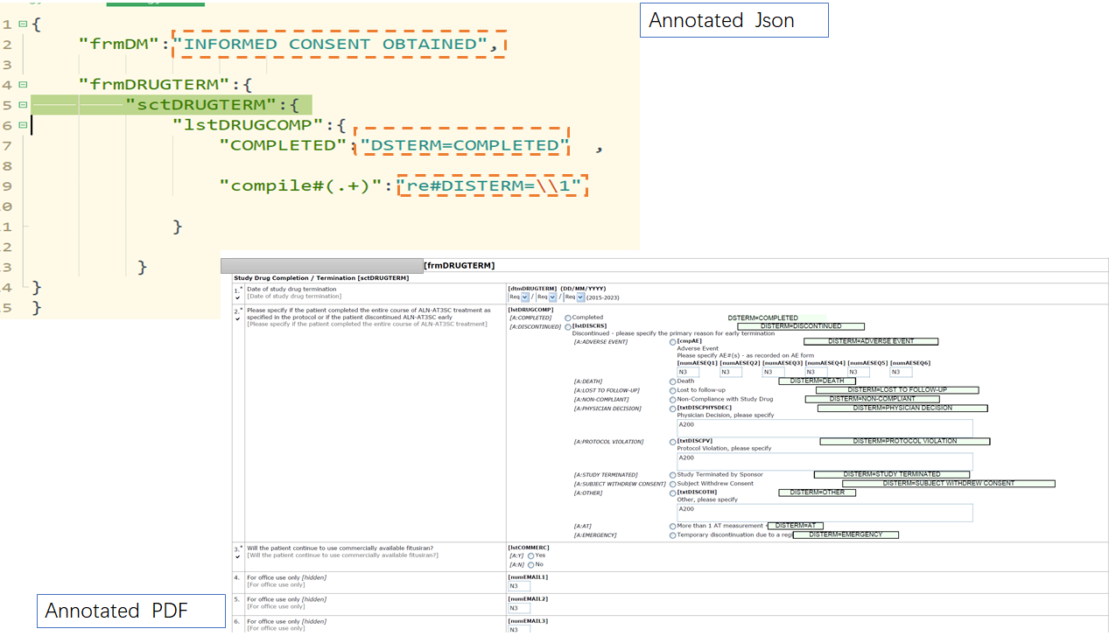

Figure . Diagram on annotated JSON and the effect on Annotated PDF

### Output Annotated PDF

After adding the annotation information into blank JSON file and finally got Annotated Json File. Just fetch it to the program, the program will automatically decode the JSON file and map back to a **MultiRegexDict** class encoded in python. We implement a simple algorithmic approach to the task of text annotation, whereby we juxtapose the output of the parsed key list against the **MultiRegexDict** object, a highly sophisticated hash-based data structure with built-in support for string-matching based mapping and regular expression-based fuzzy searching. In cases where the mapped value corresponds to a string, said textual data is promptly inscribed adjacent to the point of its detection within the analyzed text.

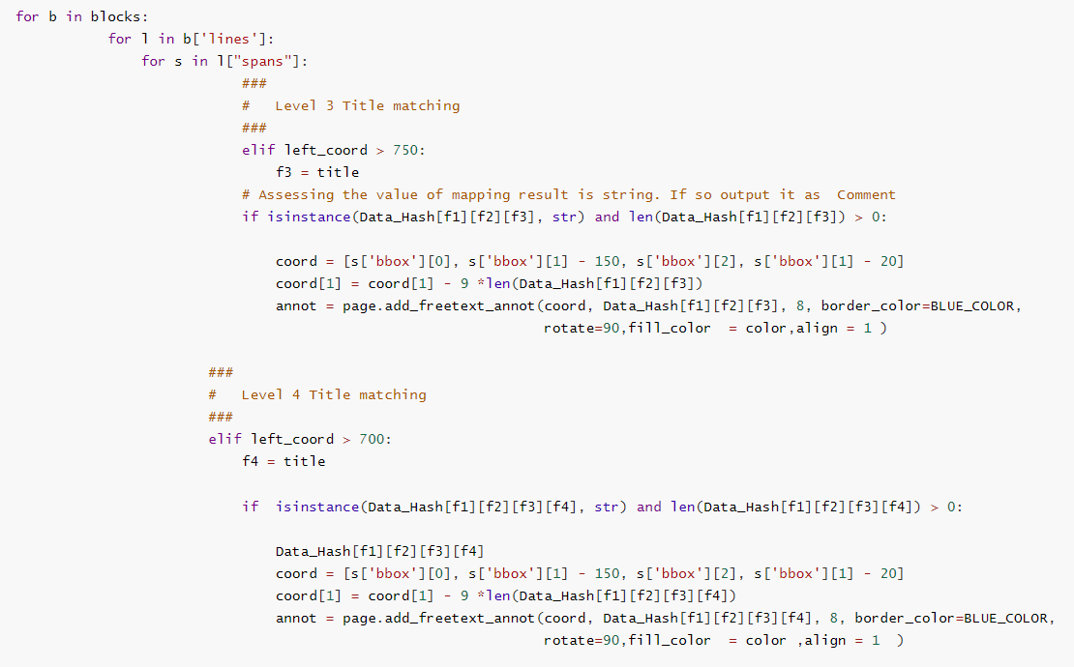

Figure .Source code on annotation mapping from CRF

### Adding Bookmarks For Inspection

For most case, all annotations will be stored automatically in TOC and add bookmarks automatically.PDF Reader have already automatic generating bookmarks on comment to TOC .

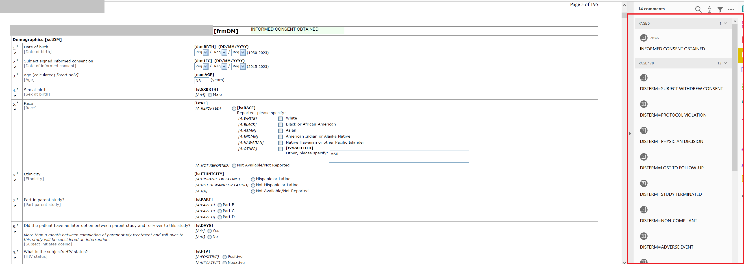

Figure . Bookmarks on comments is automated generated by PDF Reader

# Program Excution

All Python scripts are saved as .py files and have CLI（Command Line Interface）to run.

## Installation

Just download the code and install related packages by the command below:

pip install -r requirements.txt;

## Parse and extract infomation from PDF file

Fetch a blank CRF pdf file and just run commandline below to generate Blank.json:

python3 GenerateJson.py -p blank.pdf -o Blank.json ;

Then edit the Blank.json by **HbuilderX** or other editors!!

## Generate annotated CRF PDF

After adding annotation to JSON file , simply run commandline below:

python3 AddComment.py -p blank.pdf -j Annotation.json -o Annotated.pdf ;

Or we could just use a GUI to manipulate the whole process.

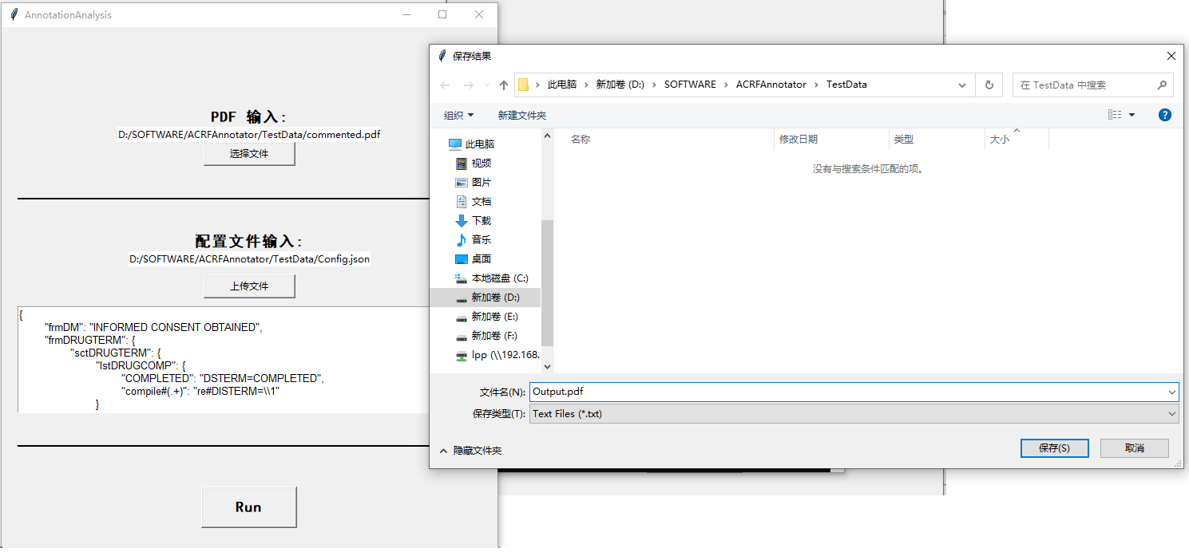

Figure . A GUI to run the worflow

# Advanced skills

## Annotation Migration

In the event of multiple versions of annotations, merging of one prioritized version with others or the migration of old version ‘s annotations to new PDF file due to formatting or sequencing changes in the input PDF document can be accomplished through the use of the ***Update*** function. This allows for the achievement of our intended goals with one-line script, here is example:

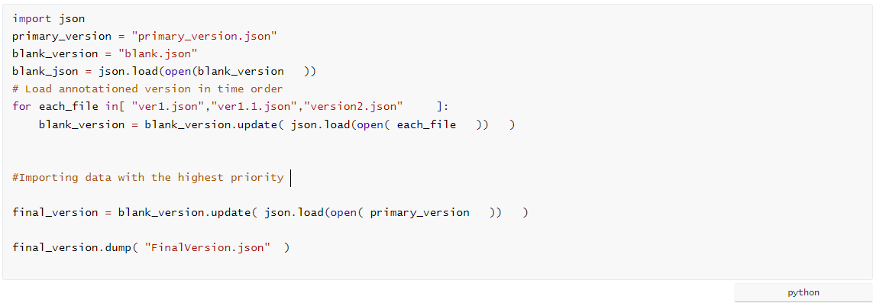

Figure .Code for annotation migration from old version to new version PDF

and then run the bash command to get the annotated PDF:

python3 AddComment.py -p blank.pdf -j FinalVersion.json -o Annotated.pdf;

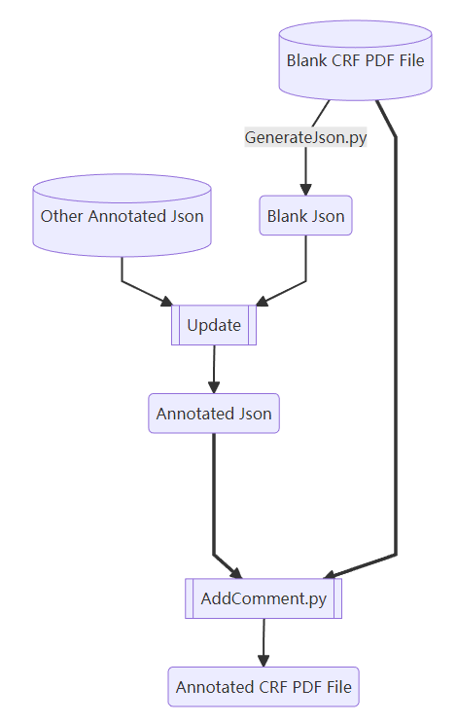

Figure ．Schematic diagram on annotation migration

## Divide-and-Conquer

Adding comments and annotations to a CRF document is a complex and laborious process for companies as these documents typically span hundreds of pages. The current methods for adding comments and annotations to CRF documents are limited to factors such as page numbers, SDS file ,resulting in low efficiency as this work is often assigned to only one person who is responsible for completing it. Using multiple dimension hash packaged JSON class obviously overcome this limit because it relies solely on the structure of the tables which is totally independent with page numbers. This implies that by carefully segmenting the document at the H1 caption in the form, we can achieve a seamless partitioning of the document. This way, different sections of the document can be allocated to different team members, who can collaborate effectively by leveraging various collaborative tools such as Github, GitLAB, mailing lists, Resilio Sync, etc. Each team member takes responsibility for ensuring the accuracy of their respective document annotations. Finally, the administrator can merge all contributions to arrive at the final output.

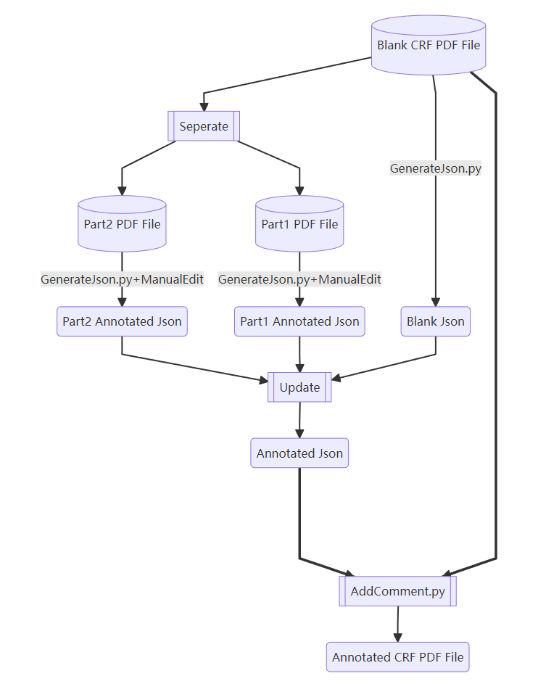

Figure . Schematic diagram on task segmentation and integration

# Limitation and [Prospect](javascript:;)

## Lmimtation

After testing, for a CRF PDF has more than 200 pages, the whole workflow but JSON manual-editing only cost 3-6 second but it still have some limitions:

### Difficulty in human comprehension.

Theoretically speaking, any tabular data can be transformed into a key-value pair format, thereby enabling its conversion into a finite-dimensional hash table. However, hash table format is machine-readable, yet it may pose challenges for human comprehension. Converting a hash table to JSON format can improve its readability, as JSON is a lightweight data exchange format that is easy to read and understand. It is also easy to parse and process in most programming languages. However, this depends on the specific content of the hash table and the design of the JSON format. In some cases, due to the nature of hash tables, especially when dealing with deep nesting, converting to JSON format may pose challenges for human comprehension. Even though many readers can now automatically format JSON to optimize it for human reading, reading JSON still requires a certain level of knowledge and skill from the user compared to the presentation of data in tabular form such as Excel. Therefore, some relevant training work may still be necessary.

## Future work

With the development of AI tools such as GPT and GLM, it is becoming increasingly feasible to convert human-readable descriptive natural language into JSON format. However, this process is highly dependent on the user's coding and expression habits, and further fine-tuning of the relevant language models is necessary. Our team is now working on meeting this demand and making continuous efforts to achieve this goal.

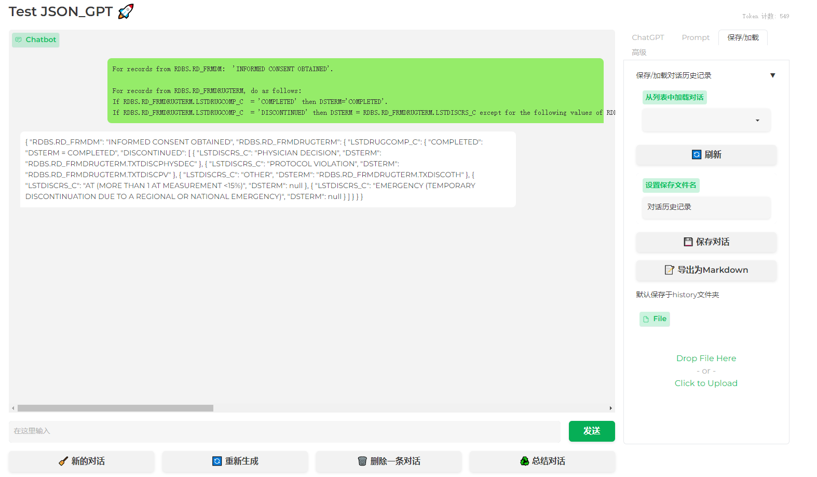

Figure .A basic GPT model design for JSON translation

# Conclusion

We have developed an intact software package include a series CLI-based tools and a GUI to semi-automatic adding comments to CRF PDF file. The core thought of algorithm is the automatic self-expandable infinite-dimension hash table for storing whole data structure of CRF PDF and associated JSON format standard which is widely used in SQL area. Thanks for the powerful capabilities of Python and the mature features of JSON related package, our package can migrate, segmentate, update, merge annotations with efficiency and quality.

# References

Foundation Python Software. n.d. "Python 3.10.4 Documentation." Accessed April 7, 2023. <https://docs.python.org/3/index.html>.

McKie, Jorj X. n.d. "PyMuPDF Documentation." Accessed April 1, 2023. <https://pymupdf.readthedocs.io/en/latest/index.html>

Lijun Chen, Jin Shi. n.d. 2022 "Automating CRF Annotation using Python." PharmaSUG China 2022-Paper AD-122.

Teresa Tang .2021 "Auto-annotation in SDTM aCRF Using R Package and SAS " Proceedings of Application Development & Technical Techniques Section, PharmaSUG China 2021.

# ACKNOWLEDGMENTS

I would like to acknowledge my wife for helping me on testing and programming and give me inspiration on algorithm designing .

# Contact Information

Your comments and questions are valued and encouraged. Contact the author at:

Name: Pengpeng Li

Enterprise: Bioevov Company

E-mail: lipengpeng@sinobiocore.com

Web: http://www.bioevov.com/

# Appendix

## Code for Data structure to store parsing PDF information

We just recursively utilizing a dictionary to package dictionary to fulfill the function of self-expandable multiple dimension hash and make some modificaion on ***__getitem__*** method to achieve regex fuzzing matching function.

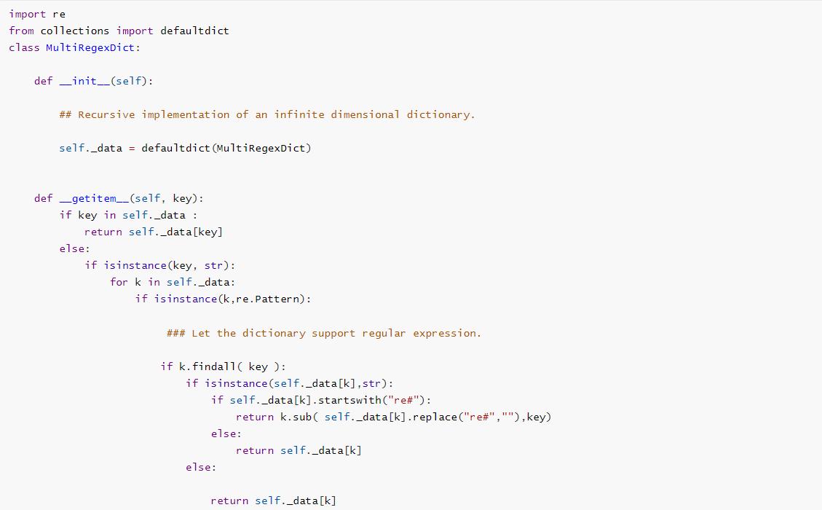

Figure . Code snippet on hash tree